SIMATS ENGINEERING
ASSESSMENT TOOL 3

COURSE NAME: COMPUTER NETWORKS
COURSE CODE: CSA07

COURSE OUTCOME COVERED
CO4:
Design network topologies star, mesh, bus, and hybrid using networking devices, transmission media, and cabling standards (BL2, BL6)
Assessment Tool Weightage: 30%

QUESTIONS: 5 Total Marks: 25
Annexure A
Comparative Analysis
Code of Conduct:IMANIYAM ANUSHKA(192525411) (Name / Reg No) certify that this submission is my original work and that I have adhered to the guidelines specified for this assessment. I understand that any violation of academic integrity rules will result in disciplinary action.Signature of the student:MANIYAM ANUSHKA
Annexure A — Comparative Analysis
The four fundamental network topologies — star, bus, mesh, and hybrid — differ significantly in cost, reliability, performance, fault tolerance, installation complexity, scalability, and maintenance. Each comparison below is supported with a summary table and a network diagram.

1. Star Topology vs Bus Topology — Cost, Reliability & Performance
Star topology is generally more expensive than bus topology because it requires a central device such as a switch or hub, along with more cabling to connect each node individually. Bus topology, in contrast, uses a single shared backbone cable, which keeps it low-cost and simple to install. However, star topology is far more reliable: the failure of one node or its cable does not affect any other device, whereas a break anywhere in the bus backbone can bring the entire network down. Performance also favours star topology, since the central switch manages and isolates traffic, reducing collisions — while bus topology degrades noticeably as more devices are added and contend for the same shared medium.
Parameter | Star Topology | Bus Topology
Cost | Higher (switch/hub + more cable) | Lower (single backbone cable)
Reliability | High — one node's failure is isolated | Low — backbone failure disrupts all nodes
Performance | Better — central device manages traffic | Degrades as more devices share the medium
Table 1: Star vs Bus — Cost, Reliability and Performance
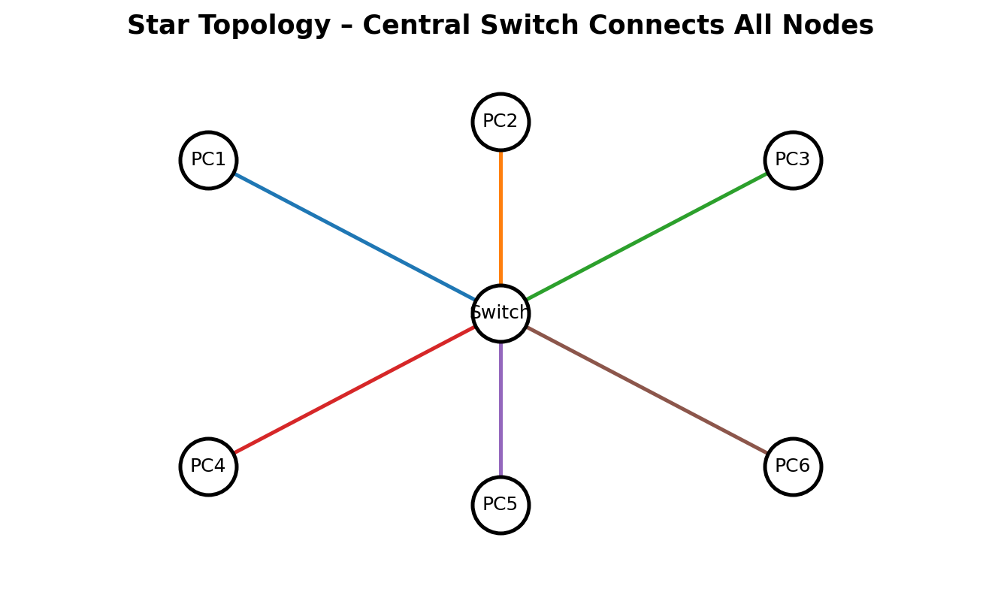
Fig. 1(a): Star Topology — all nodes connect to a central switch/hub
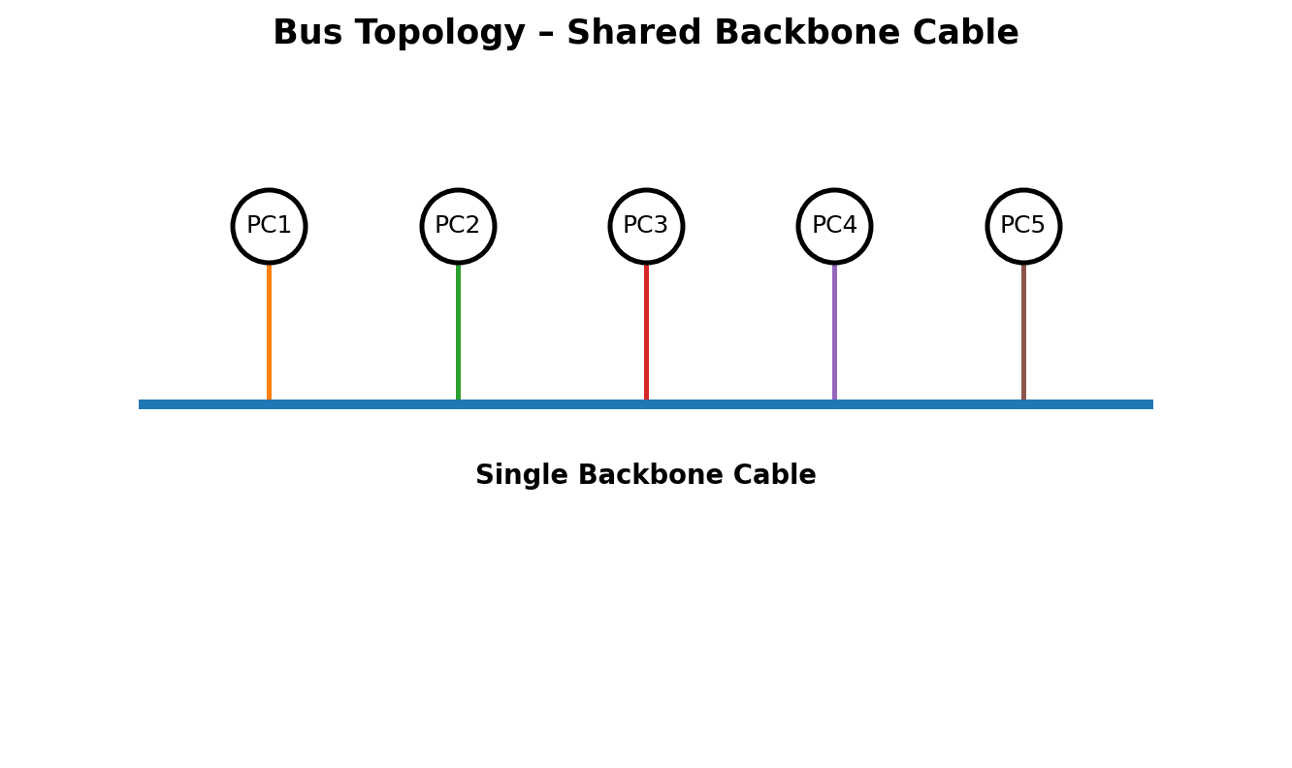
Fig. 1(b): Bus Topology — all nodes share a single backbone cable

2. Mesh Topology vs Star Topology — Fault Tolerance
Mesh topology offers very high fault tolerance because every node connects to multiple other nodes, creating several alternate paths for data. If one link fails, traffic can simply be rerouted through another path without any disruption to communication. Star topology, by comparison, has only moderate fault tolerance — an individual node's failure does not affect the rest of the network, but failure of the central hub or switch stops the entire network from functioning. This makes mesh topology considerably more robust and dependable for critical, high-availability environments.
Parameter | Mesh Topology | Star Topology
Redundant paths | Multiple paths between every pair of nodes | Only one path — through the central device
Single point of failure | None | Central hub/switch
Fault tolerance | Very high | Moderate
Table 2: Mesh vs Star — Fault Tolerance
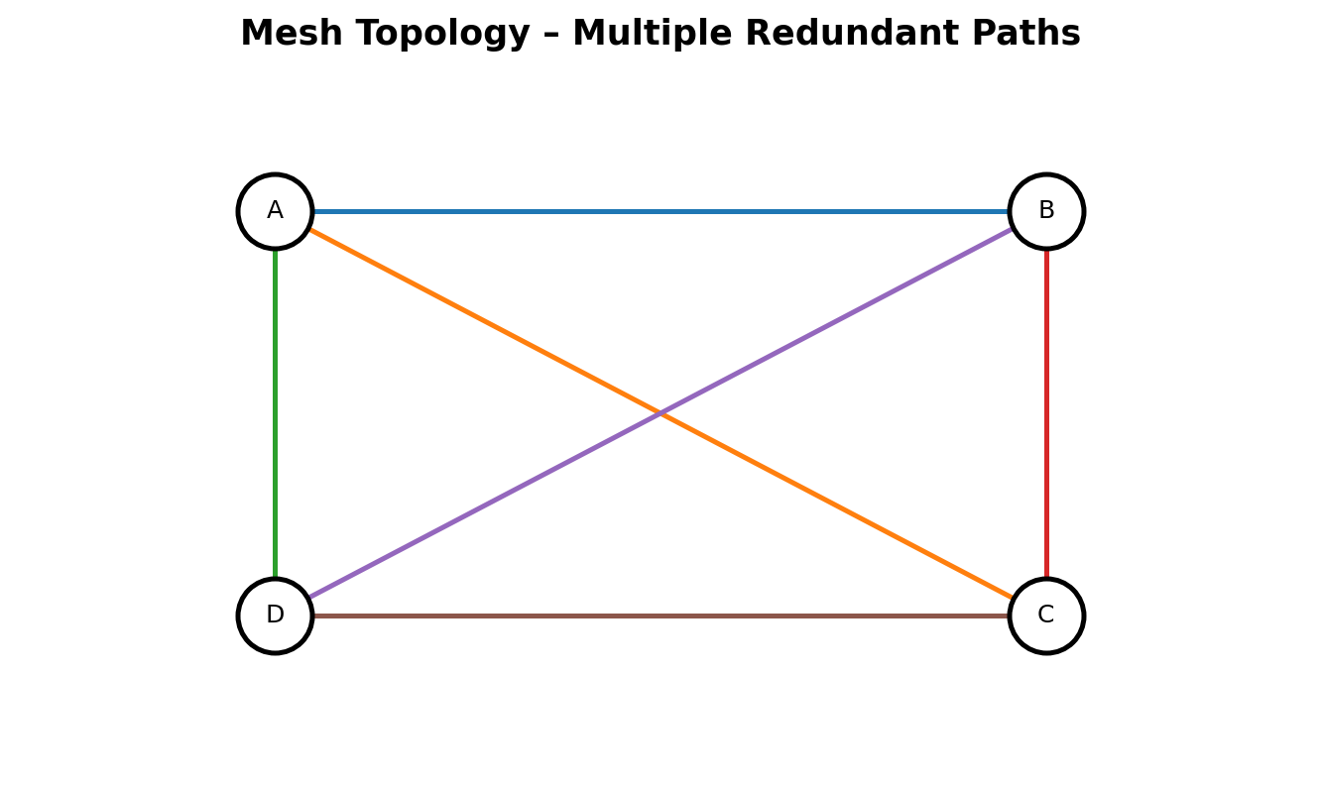
Fig. 2: Mesh Topology — every node interconnected, providing redundant paths

3. Bus Topology vs Mesh Topology — Installation Complexity
Bus topology is simple and quick to install because it needs only a single backbone cable with minimal connection points, making it well-suited to small networks. Mesh topology, on the other hand, is highly complex to set up, since every node must be individually connected to every other node — requiring a very large number of cables and ports. This complexity grows rapidly as more devices are added, making mesh topology far more time-consuming and costly to implement than the straightforward wiring of a bus network.
Parameter | Bus Topology | Mesh Topology
Cabling required | Minimal (one backbone cable) | Very high — n(n-1)/2 links for full mesh
Installation effort | Low, quick to set up | High, grows sharply with node count
Suitability | Small, simple networks | Small, high-reliability critical networks
Table 3: Bus vs Mesh — Installation Complexity

4. Hybrid Topology vs Star Topology — Scalability
Hybrid topology is highly scalable because it combines two or more topologies — such as star, mesh, or bus — allowing the network to expand flexibly to meet organizational needs, with new segments added without disturbing the existing structure. Star topology is also scalable, but only to a limited extent, since it depends on the port capacity of the central device; once that device reaches its limit, further expansion requires additional switching hardware. Hybrid topology therefore offers noticeably greater scalability than a pure star design.
Parameter | Hybrid Topology | Star Topology
Basis of design | Combines multiple topologies (e.g., star + bus) | Single central device
Expansion | Flexible — new segments added independently | Limited by central device's port capacity
Scalability | High | Moderate
Table 4: Hybrid vs Star — Scalability
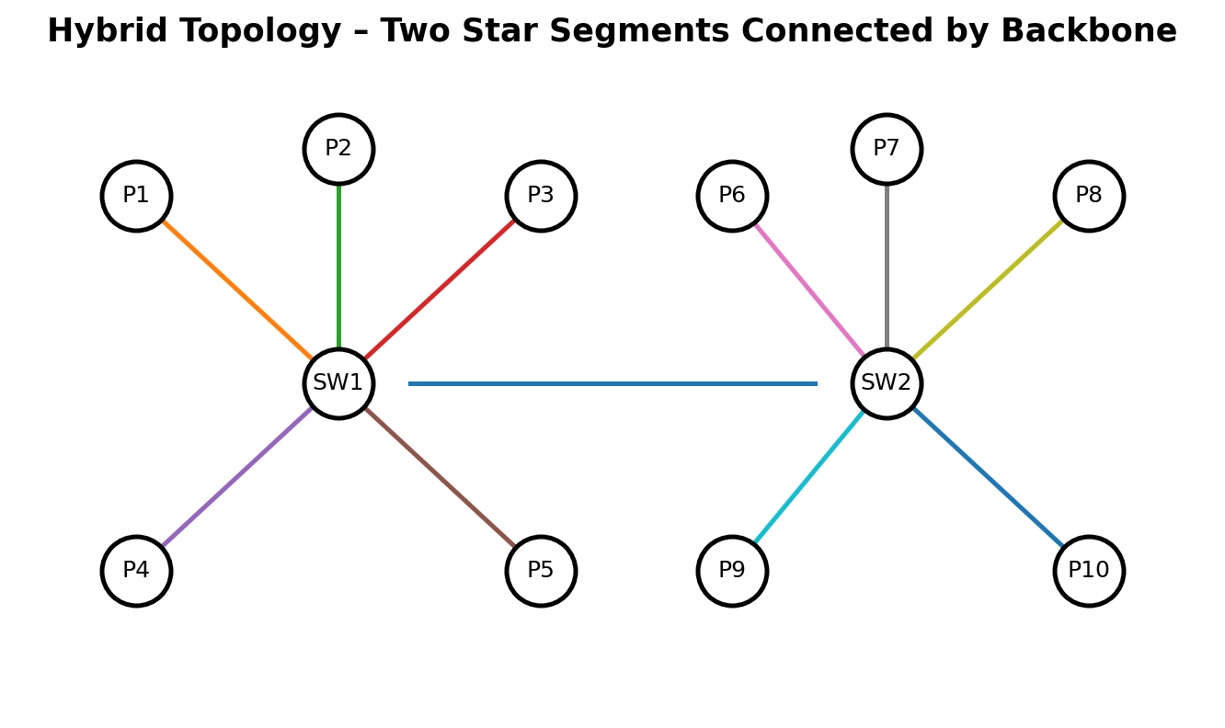
Fig. 3: Hybrid Topology — two star segments joined by a backbone link

5. Maintenance Comparison Across All Four Topologies
Star topology is relatively easy to maintain because problems can be quickly identified and isolated to a single node or cable. Mesh topology, despite its high reliability, is difficult to maintain owing to its complex structure and large number of connections, which makes troubleshooting time-consuming. Bus topology is harder to maintain than star topology because a fault anywhere in the backbone cable can disrupt the whole network and can be difficult to locate. Hybrid topology carries moderate maintenance complexity — it benefits from flexibility, but managing several combined topologies together requires careful monitoring and skilled administration.
Topology | Fault Isolation | Troubleshooting Effort | Maintenance Level
Star | Easy — isolated to node/cable | Low | Easy
Bus | Hard — backbone faults affect all | High | Difficult
Mesh | Complex — many links to check | Very high | Difficult
Hybrid | Depends on combined segments | Moderate | Moderate
Table 5: Maintenance Comparison — Star, Bus, Mesh and Hybrid

Overall Summary
The table below consolidates all comparison parameters discussed above across the four topologies for quick reference.
Criteria | Star | Bus | Mesh | Hybrid
Cost | High | Low | Very High | High
Reliability | High | Low | Very High | High
Performance | Good | Degrades with load | Excellent | Good
Fault Tolerance | Moderate | Low | Very High | High
Installation Complexity | Moderate | Low | Very High | High
Scalability | Moderate | Low | Low | High
Maintenance | Easy | Difficult | Difficult | Moderate
Table 6: Overall Comparison of Star, Bus, Mesh and Hybrid Topologies

